**BOOK MY SHOW**

**Login page:**

Options: Gmail, google, contact number with OTP.

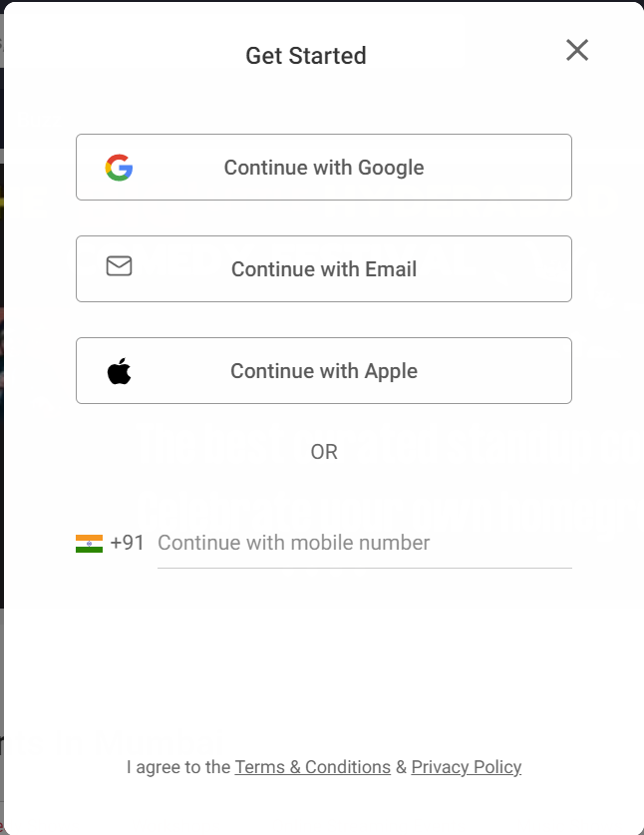

**Home page:   
header: logo, search, location, sign in, menu, left navigation bar and right navigation bar**

**Advertisement: Carousel (to show advertisement) As below.**

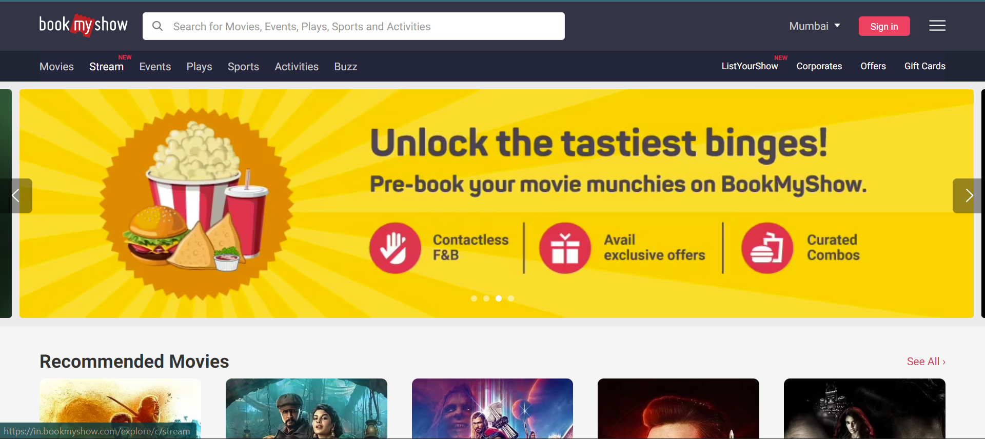

**Body Page:**

**Lift side Filter page: Date, Language, Categories, Price.**

**Right side Listing Page: Present movies running in theatre after clicking on movie poster then book a ticket, next show timing, select seat, payment page.**

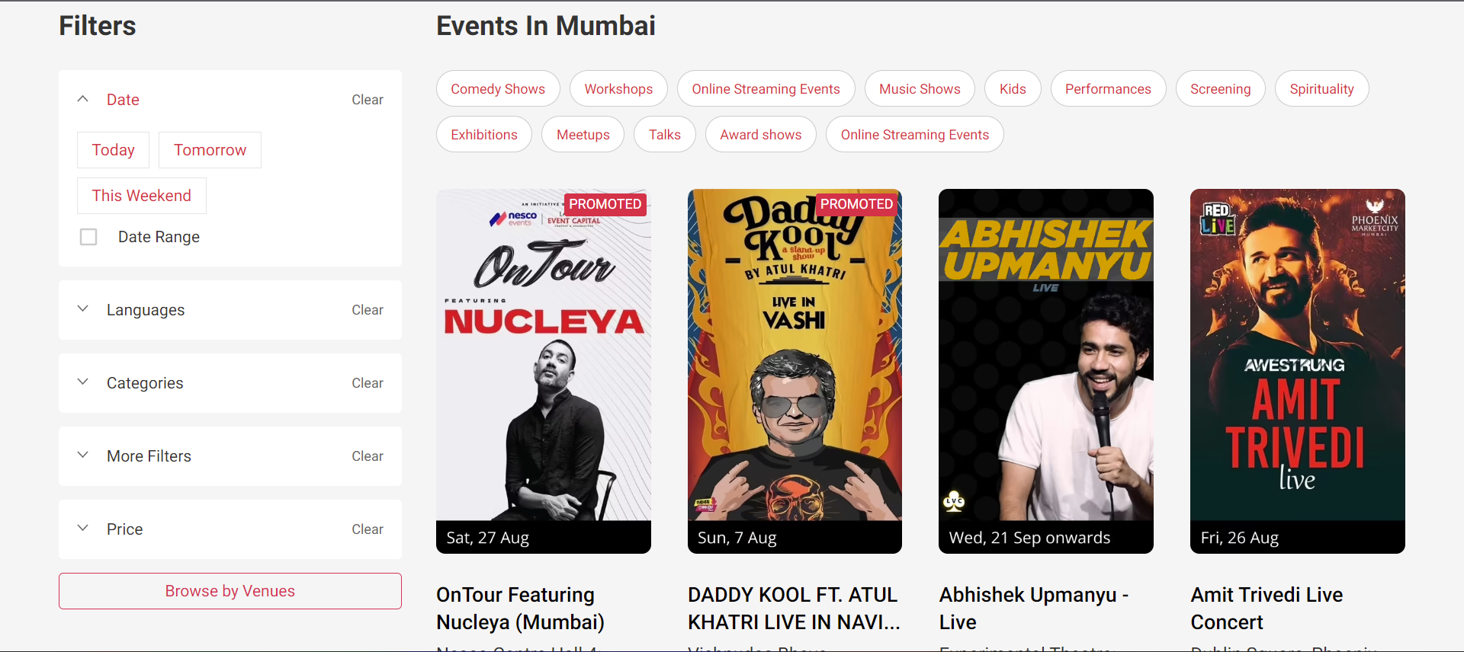

**Footer Page:  
copy rights and 24/7 Customer care, website mail id.**

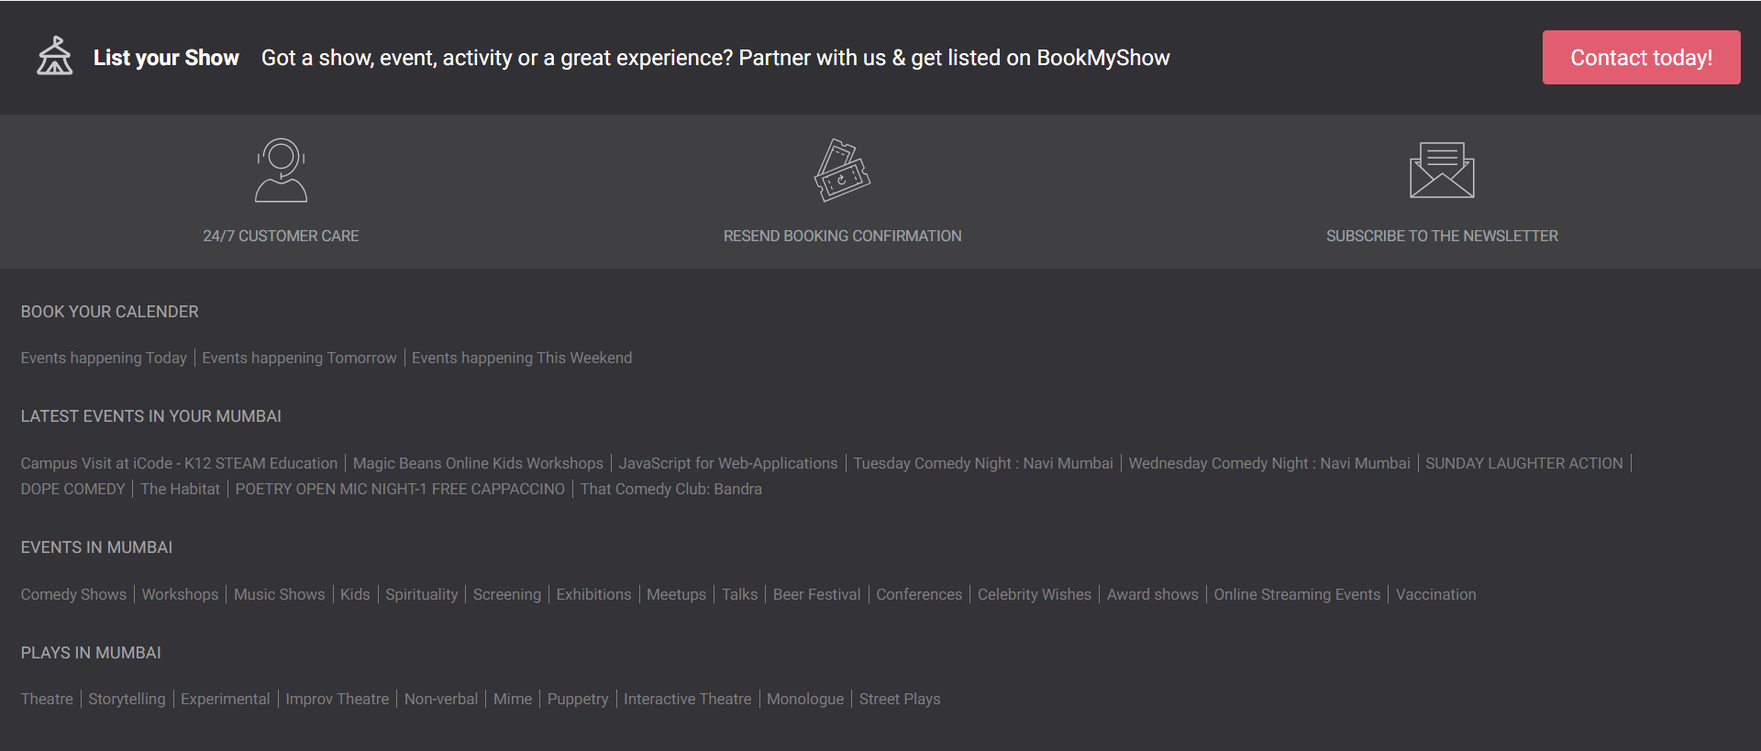

**🡨🡨🡨🡨Completed 🡪🡪🡪🡪**